A Task focused approach to
support interrupt recovery and sharing over the web

Abstract
In this paper we describe the design and evaluation of our prototype which explores a task focused interface that helps the user in handling interrupts and sharing multi-session web tasks more efficiently.

Keywords
Web browser, Tasks, Multi-session, Interrupts, Resumption

ACM Classification Keywords
H.5.4 Information interfaces and presentation: Hypertext/Hypermedia;
H.5.2 [Information Interfaces and Presentation]: User Interfaces – user-centered design, graphical user interfaces (GUI), prototyping, evaluation/methodology;

Introduction
Over the past decade, tasks accomplished using a web browser have increased in complexity and density [16][5]. Users are spending increasingly more time in their web browsers on various tasks, ranging from shopping to planning a vacation to researching a topic. The interrupt ridden multi-tasking culture forces them to continuously switch back and forth between various tasks [6][4]. Users are hence finding it increasingly difficult to accomplish a task in a single session [7]. About 50-80% of web pages visited by users are re-visits [1]. 83% of users in a prior research reported resuming an information seeking task on the web [16] and 24% of them resumed the task after a period of more than a week of suspending the task. This necessitates tools to support the user in recovering the suspended task. But despite the wide spread presence of the problem [15], the current generation of browsers have virtually no support to help the user in handling the interruption and resumption of tasks.

Related work
Previous work in this area has tried to address this problem by building interfaces, either as part of the browser by extending it [14][16][13] or as a separate helper application to be used in tandem with the web browser [7], in handling multiple tasks more efficiently and helping the user in faster recovery of the suspended context when resuming a task.

Searchbar [16] creates new tasks based on the search queries performed by the user. Tasks are shown in the sidebar and each task has a summary page with user annotations and user favorited links if any.
Prior work by MacKay [14][13] includes a horizontal task-bar below the URL bar to manage tasks. Tasks can be stopped and resumed. Session highlights [7] shows thumbnails of the pages visited by the user, grouping them spatially based on the time the page was accessed.

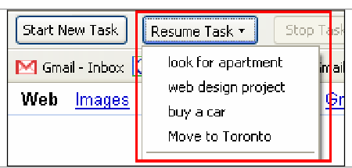
Task management in a similar system by Mackay [13]

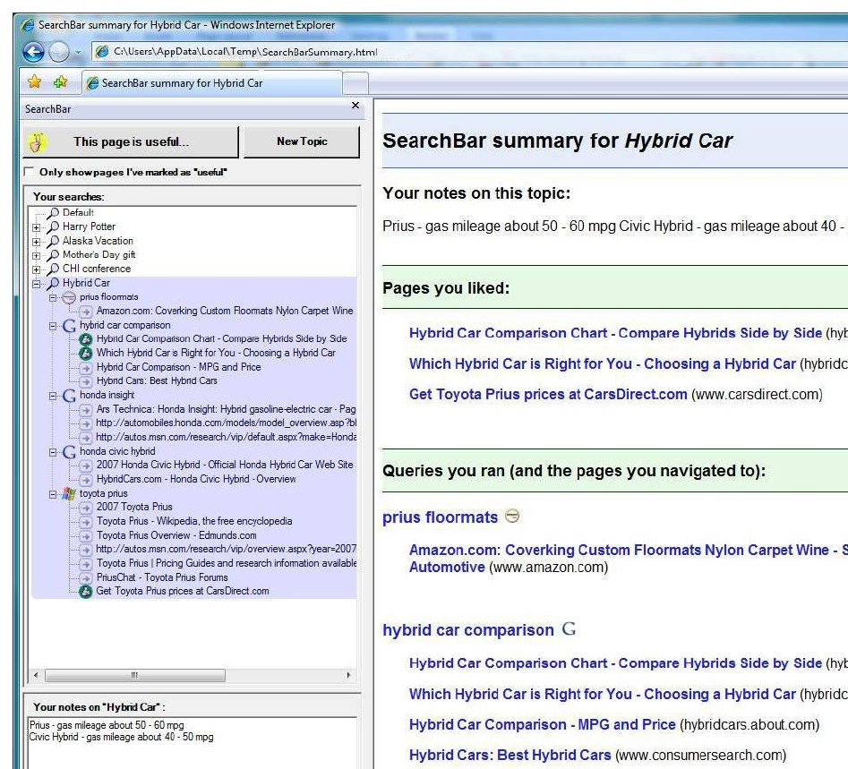
Multiple search-tasks in Searchbar [16]

Though binding the creation of a new task to user's search activity seems like a good approach for a large majority of users who resort to passive storage mechanisms for task resumption [16], it remains to be seen whether users, especially those who resort to active task recovery mechanisms, prefer the default binding of all tasks to a search activity. Moreover, we believe that the previous work does not adequately solve the problem of information overload and clutter with respect to all the information artifacts of bookmarks, tabs and history mechanisms.

Motivation

Task focused nature of the user experience over the web

We believe that users do not experience the web in terms of URLs, but instead interact through mental models at a much higher level of abstraction [4]. Yet they have remained as the basic unit of interaction in the browsers. Built for the static web, this level of abstraction is becoming less usable in today's age of dynamic web and information abundance. This could explain why tabs, bookmarks and history, three different representations of an URL, are facing severe scalability and usability issues and prior studies [5][11] have shown that they do not fully serve their intended purpose and are not used by a majority of the users effectively. History, bookmarks and tabs become cluttered and unusable over prolonged usage incurring a significant maintenance overhead which most users are not willing to invest in.
We propose a prototype where a task is promoted as the basic unit for interaction and manipulation in the browser. Tabs, bookmarks and history become part of a task and bound to its life-cycle of creation, suspension, recovery, completion and deletion. We hypothesize that this design will help users to manage the information overload, interruption and subsequent resumption of a task more efficiently than similar systems [14][16][13][7].
Requirements gathered from informal user study

We obtained several insights during the informal user study performed in the analysis stage with {n} users. We observed how more participants relied on searching for revisiting a page, either using a search engine or the auto-complete feature of the URL bar in browsers as they typed in keywords, rather than using bookmarks or history.

We found that the history feature was the least used among the users. We attribute this to the poor visual discernibility of the history items and lack of context that the user can easily relate with, which then necessitates substantial cognitive load to process and identify the items. Some of our participants didn't have a clue on how to access the history. These observations coincides with that made by Searchbar [16] and by other researchers over the past decade [9][15][12][11].

We observed several coping strategies employed by participants for saving their task states for easier resumption: emailing URLs along with notes to themselves or noting down URLs in a document along with annotations. These strategies have also been observed by other researchers [8][16].
We believe that using emails or text files for task resumption, as supposed in bookmarks or history has three distinct advantages.
1. It provides a powerful reminder of the pending tasks [6][4]. This ability was observed to be the most useful by participants in the study conducted on a similar system [14]. This is akin to what is observed in offices where people tend to organize their documents in piles and place them in different visible places along their workspace to act as reminders [8][4].
2. It has the ability to carry annotations, which adds more contextual information pertaining to the task.
3. It is accessible across multiple computers (work, home) and users find it more reliable as it is less prone to loss, for example due to operating system upgrades as Jones observes [8].

We have taken advantage of these three features in our design by having 1. high visibility of all the tasks, including the suspended tasks, 2. annotations for each page and 3. easy sharing of tasks across computers.

Stronger information scent through increased visibility of tasks:
We observed that reduced visibility of various information artifacts pertaining to a task seemed to be major problem that turned users into information gluttons. For example bookmarks in folders (as hierarchical collections) tend to organize as well as obscure information. A majority of users we interviewed underestimated the number of bookmarks they had. We believe that this is one of the primary reasons that bookmarks do not scale well [2]. A majority of users who used bookmarks were unhappy with the current state of their bookmarks. This is similar to the observations made in prior work [8]. 68% of users in a previous study [14] were found accessing bookmarks only through the bookmarks tool bar which remained visible at all times.

Bookmarks were identified as a heavily used within-task navigational aid in prior studies [9]. We believe that having bookmarks, history and tabs as a component of the task could result in multiple benefits:
. Decrease in search and navigation effort of information relevant to a task
. Increased visibility, which serves as a reminder of pending actions
. Associating the life of the items with the life of the tasks and thereby significantly reducing the clutter and information glut and consequently the overhead of maintaining the relevancy to the task at hand.

We have tried to mitigate the problem of visibility by 1. limiting the number of levels of hierarchy under a task and 2. providing an outline in a side bar containing the thumbnails of all the pages under a task along with their annotations. We believe that showing thumbnails of pages on-demand minimizes the cost of task resumption [6] and also helps the user in the process of obtaining a quick overview of all the pending tasks.

We wanted to design a system that
- added as little overhead as possible for the user when managing tasks,
- does not confuse the (naive) user by overwhelming with additional interfaces when he/she is not working on a task,
- maintained easy visibility of all tasks,
- constrained all information artifacts that are associated with the user's tasks, such as bookmarks, history and annotations, to the scope and life of the task,
- made it trivial to share a task with all its related items across computers.

Evaluation

Discussion
Participants reported only a slight preference for our system over the normal web-browser. This is as we had expected given the short duration of evaluation of the system. Experiments on similar systems [16] has shown similar results, in that users prefer the experimental system only marginally over the control system after their initial exposure to the system. It is over the course of using the system for about a week [16], where they create and resume various suspended tasks, the users are able to appreciate the improved support that the experimental design offers to their activities.

Limitations

Conclusion
We believe that the browser is becoming the operating environment where users are beginning to spend a significant percentage of their computer-time and a place where an increasing number of their interrupts occurring over the course of the day are handled. Consequently more effort will be devoted in trying to reinvent the information and task management structures present in the operating system such as Groupbar [17], Tasktracer [3] etc for the browser . It should however be noted that features such as suspension and resumption of tasks are typically not available under current operating systems. We believe that interrupt management is a necessary feature [4] in the browser and hope that they become a standard feature of the web browsers and benefits a wide range of users.

Future work
Experiments on similar systems [16] has revealed that participants begin to see the benefit of the design after about a week when they are resuming tasks suspended the week before. Due to time constraints, we were not able to perform a study spanning a week. A longitudinal study comparing our prototype with similar systems could reveal valuable insights for improving the system design.

We would like to consider adding the following features to our system in future:
. Users have expressed desire for the ability to have multiple categories of bookmarks such as permanent, frequent, transient [14][1]. We could explore having multiple categories of tasks or working spheres as characterized by prior research [4] that reflects the different work-flows inherent to the tasks.
. Automatic sensing of the current context of the user [10] and taking advantage of the information to reduce the overhead for the user in creating and maintaining tasks. For example, user could be given a hint that the current page in the default task has greater cohesiveness with one of user's active or suspended tasks. If user then chooses to, the system should make it trivial to associate the page with the task.
. Replay of task history to aid recovery [6].
. User selectable modes to minimize interruptions, for example by selectively blocking notifications from other concurrent tasks. In case of user initiated switches, we could add mechanisms that reminds the user to return quickly to the primary task [6], for example a count-down timer that can allow the users to set an upper bound on the diversion time from the primary task.
. Displaying statistics and visual representations of the task interruption cycle of the user to help them better understand where their time spent. The resulting awareness could enable the user to handle interrupts more effectively.

Acknowledgements
We thank .. {}

References

[1] Adar, E., Teevan, J., and Dumais, S. T. 2008. Large scale analysis of web revisitation patterns. In Proceeding of the Twenty-Sixth Annual SIGCHI Conference on Human Factors in Computing Systems (Florence, Italy, April 05 - 10, 2008). CHI '08. ACM, New York, NY, 1197-1206.

[2] Abrams, D., Baecker, R., Chignell, M. 1998. Information archiving with bookmarks: personal Web space construction and organization, In Proceedings of the SIGCHI Conference on Human Factors in Computing Systems (Los Angeles, CA, USA, April 18 - 23, 1998). CHI '98. ACM, New York, NY, 41-48.

[3] Dragunov, A. N., Dietterich, T. G., Johnsrude, K., McLaughlin, M., Li, L., and Herlocker, J. L. 2005. TaskTracer: a desktop environment to support multi-tasking knowledge workers. In Proceedings of the 10th international Conference on intelligent User interfaces (San Diego, CA, USA, January 10 - 13, 2005). IUI '05. ACM, New York, NY, 75-82.

[4] González, V. M. and Mark, G. 2004. "Constant, constant, multi-tasking craziness": managing multiple working spheres. In Proceedings of the SIGCHI Conference on Human Factors in Computing Systems (Vienna, Austria, April 24 - 29, 2004). CHI '04. ACM, New York, NY, 113-120.

[5] How many tabs do people use. http://dubroy.com/blog/how-many-tabs-do-people-use-now-with-real-data

[6] Iqbal, S. T. and Horvitz, E. 2007. Disruption and recovery of computing tasks: field study, analysis, and directions. In Proceedings of the SIGCHI Conference on Human Factors in Computing Systems (San Jose, California, USA, April 28 - May 03, 2007). CHI '07. ACM, New York, NY, 677-686.

[7] Jhaveri, N. and Räihä, K. 2005. The advantages of a cross-session web workspace. In CHI '05 Extended Abstracts on Human Factors in Computing Systems (Portland, OR, USA, April 02 - 07, 2005). CHI '05. ACM, New York, NY, 1949-1952.

[8] Jones, W., Bruce, H., and Dumais, S. 2001. Keeping found things found on the web. In Proceedings of the Tenth international Conference on information and Knowledge Management (Atlanta, Georgia, USA, October 05 - 10, 2001). CIKM '01. ACM, New York, NY, 119-126.

[9] Kellar, M., Watters, C., and Shepherd, M. 2006. The impact of task on the usage of web browser navigation mechanisms. In Proceedings of Graphics interface 2006 (Quebec, Canada, June 07 - 09, 2006). ACM International Conference Proceeding Series, vol. 137. Canadian Information Processing Society, Toronto, Ontario, Canada, 235-242.

[10] Kersten, M., Murphy, G.C. 2007. Using task context to improve programmer productivity. In Proceedings of the 14th ACM SIGSOFT International Foundations of Software Engineering Conference (Portland, Oregon, USA, November 05 - 11, 2006). SIGSOFT 2006 FSE-14. ACM, New York, NY, 1-11.

[11] Tauscher, L., Greenberg, S. 1997. How people revisit web pages: empirical findings and implications for the design of history systems. International Journal of Human-Computer Studies, v.47 n.1, p.97-137, July 1997.

[12] Tauscher, L., Greenberg, L. 1997. Revisitation patterns in World Wide Web navigation, In Proceedings of the SIGCHI Conference on Human Factors in Computing Systems (Atlanta, GA, USA, March 22 - 27, 1997). CHI '97. ACM, New York, NY, 399-406.

[13] MacKay, B. and Watters, C. 2009. Building support for multi-session tasks. In Proceedings of the 27th international Conference Extended Abstracts on Human Factors in Computing Systems (Boston, MA, USA, April 04 - 09, 2009). CHI EA '09. ACM, New York, NY, 4273-4278.

[14] MacKay, B. and Watters, C. 2008. Exploring multi-session web tasks. In Proceeding of the Twenty-Sixth Annual SIGCHI Conference on Human Factors in Computing Systems (Florence, Italy, April 05 - 10, 2008). CHI '08. ACM, New York, NY, 1187-1196.

[15] Byrne, M. D., John, B. E., Wehrle, N. S., Crow, D. C. 1999. The tangled Web we wove: a taskonomy of WWW use. In Proceedings of the SIGCHI Conference on Human Factors in Computing Systems: the CHI is the limit (Pittsburgh, PA, USA, May 15 - 20, 1999). CHI '99. ACM, New York, NY, 544-551.

[16] Morris, D., Ringel Morris, M., and Venolia, G. 2008. SearchBar: a search-centric web history for task resumption and information re-finding. In Proceeding of the Twenty-Sixth Annual SIGCHI Conference on Human Factors in Computing Systems (Florence, Italy, April 05 - 10, 2008). CHI '08. ACM, New York, NY, 1207-1216.
[17] Smith, G., Baudisch, P., Robertson, G. G., Czerwinski, M., Meyers, B., Robbins, D., & Andrews, D. 2003. GroupBar: The TaskBar evolved. In Proceedings of OZCHI 2003.

